Since access tokens aren't valid for an extended period because of security reasons, a refresh token helps to re-authenticate a user without login credentials. This Refresh token is never exposed to the client-side Javascript, even if our access token gets compromised it'll be expired in a very short duration.

So, we will be sending two tokens instead of one, an access token and a refresh token. The access token will contain all the user information and will be stored in Javascript runtime, but the refresh token will be stored securely in an HTTP-only cookie.

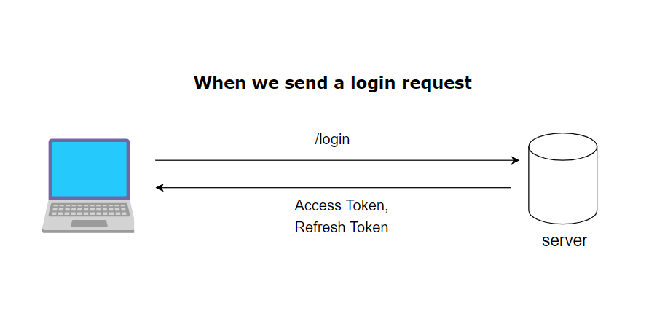

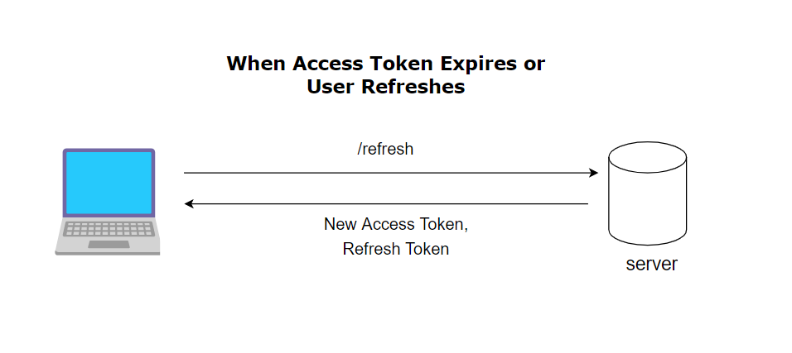

Below are the steps to do revoke your JWT access token:
- When you do log in, send 2 tokens (Access token, Refresh token) in response to the client.
- The access token will have less expiry time and Refresh will have long expiry time.
- The client (Front end) will store refresh token in an httponly cookie and access token in local storage.
- The client will use an access token for calling APIs. But when it expires, you call auth server API to get the new token (refresh token is automatically added to http request since it's stored in cookies).
- Your auth server will have an API exposed which will accept refresh token and checks for its validity and return a new access token.
- Once the refresh token is expired, the User will be logged out.

